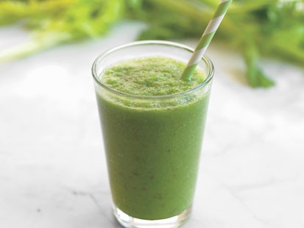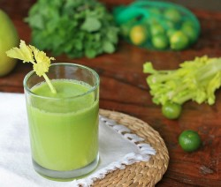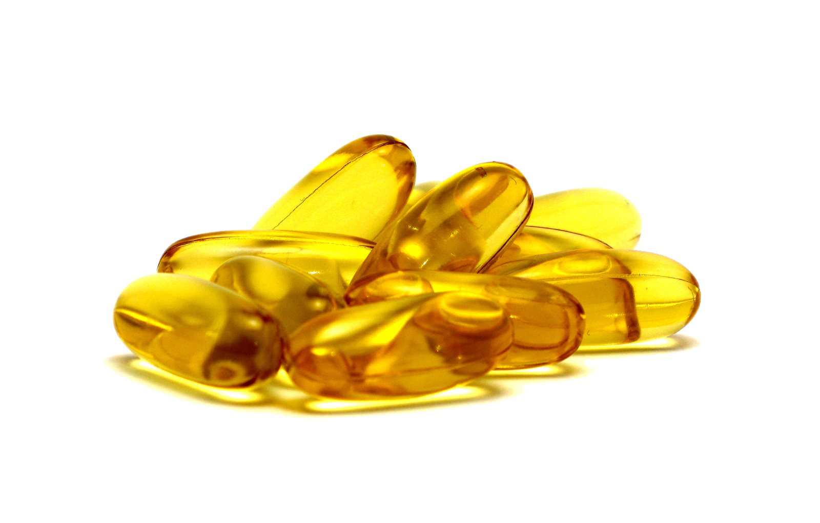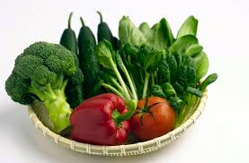

* Cathy Maxwell’s

$97 Value

http://www.healthyhabitsutah.com

**FREE**

**REPORT**

**5 Secrets to a Healthier,  
Sexier Spring Body**

# Health & Wellness Seekers,

# I’m Cathy Maxwell, founder of [HealthyHabitsUtah.com](http://www.healthyhabitsutah.com) with weekly articles from moi about alkalized living (also know to me as plant passionate living as I tend to lean on the vegan side), health, happiness, spirituality and all things good.

My physical health journey began in 1990 when I was in an awful snow skiing accident. Surgeries have put me back together, however my body was so crippled and acidic, I was diagnosed with both Fibromyalgia and Chronic Fatigue. Both conditions are a direct result of a high level of acidosis- although I didn’t have that information at the time.

I learned of Dr Robert O Young and his “New Biology” about five and a half years ago. It made sense. Keeping my body alkaline has allowed me to regain my health, gives me healthy blood cells, high energy levels, keeps me lean, has cleared up brain fog, gives me a clear complexion, has cleared my femoral artery blockage and there are so many more benefits I could go on and on.

Two years ago my neck was rebuilt with three new disks, a metal plate and eight screws. My healing from this surgery was very successful. What I am facing now is Deep Brain Stimulation Surgery. I have had an Essential Tremor for twenty five years.

My first of three surgeries is scheduled for early June. This will be my twenty sixth surgery. Needless to say my body has been through more than most can imagine. Yet through alkalizing, my body is in better shape than most.

I have been revving up the alkalinity train so that my body is fully prepared and has alkaline reserves ready. My goal is to be in the best health possible walking into the hospital so that my body will be at its peak state to fight off hospital infections and to more easily recover from the drugs and anesthesia. You can follow my journey by following my blog at [blog.healthyhabitsutah.com](http://blog.healthyhabitsutah.com).

I have learned to take personal responsibility for my well-being at the deepest level imaginable. Now I want to show you how to take charge of your own health and radiance with some plant passionate living –green juicing, alkalizing and a little sassiness!

Each and every one of us has the power to change the wellness in our families and in our kitchens. By making these five simple changes consistently, you can see improvements in the quality of your life. It is up to you. I can tell you about them, but only you can do them. Learn to live like you really mean it. No one can take better care of you than wise, brilliant, capable and STRONG you..

Make these five simple Healthy Habits stick. Get inspired – print it out, hang it on your fridge and read it daily! This step alone will have a big impact on your life. Remember you are the change you’ve been waiting for.

Juice Up!

***Cathy Maxwell***

PH Miracle Certified Coach

PH Miracle Certified Microscopist

Column 2

**Energy Filled Green Drink**

It’s my favorite morning beverage. This recipe makes about 32 ounces after processing through a juicer.

2 large cucumbers (peeled if not organic)

A colander full of spinach (or kale, chard etc)

6 stalks of celery

**Green Avocado Smoothie**

Mix these ingredients in a blender. Adjust the lime according to your taste buds!

2 avocados

Juice of 2 limes

1 cucumber

Handfuls of spinach

Few ice cubes

Ionized water (or filtered water)

RECIPES

What is Alkalinity?

* **The Right Water**: Fully hydrating the body with lots of good quality water is the quickest and easiest way to reach and maintain good health. I encourage all of my clients to drink at least four liters (about one gallon) of water each day. Yes, I said four liters a day, but don’t worry I will tell you how to do it!
* I drink one liter of water when I wake up in the morning. And guys, to get four to six liters of water in my body every day, I need to gulp my water, not sip, but gulp my water. If I just sipped my water all day there is no way I would get the necessary water into my body that it needs. That doesn’t mean I have to gulp my water so that its running down my face in front of my new boss or, on a hot date .
* I drink another liter by noon, one by three and my last one by six pm. After doing that for a few weeks you can see that you may be able to fit another liter or two in the mix. Just make sure you stop drinking water in this quantity by six pm so that you can get a good night sleep with no bathroom interruptions. My Body cells are only as healthy as the fluids they are bathed in. Unfortunately, the water you need is not flowing from your tap and it’s not in your bottled water either. Those water sources are acidic. Ionized water is the best choice. This is water that is highly alkaline, highly charged and full of potential energy.

The Secrets!

**Breathing:** breathe good air all day long… don’t stop breathing

**Green Juice:** When you drink your vegetables your body is receiving a greater concentration of rapidly usable alkaline salts, vitamins, minerals, chlorophyll, and electrons, and can assimilate them more easily and rapidly. I start every day with a green juice or smoothie. For added alkalinity have two or three!

**Avoid Dairy:** Dairy products contain acidic hormones and pesticide residues, microforms, mycotoxins, and saturated acid fats. Milk sugar also causes the biological transformation of healthy body cells into bacteria, yeast and mold. Dairy is known to be the leader of all foods in forming sticky mucus.

**Food Combine:** To ensure proper alkalization of food in your elementary canal, food combining is an important consideration. Here are the basics:

**Fruits:** Eat high sugar acidic fruit on its own-and only in moderation. They are not a friend to alkalinity. The exceptions are Alkalizing Fruits: lemon, lime, grapefruit, raw tomato, avocado, red, yellow green and orange peppers. Enjoy as many as you would like.

**Vegetables:** eat all the vegetables you would like. Get creative with green salads and finger foods. Vegetables may be eaten with either Protein meals of Starch meals or alone.

**Healthy Alkalizing Mono & Polyunsaturated Oils:** Use these with alkaline vegetables, alkalizing fruit, starches, seeds, nuts and avocados. I use Omega 3-6-9 Essential Oil Blend.

**Protein Meal:** Eat protein with all the vegetables and/or all the alkalizing fruits you would like. i.e.: a piece of grass feed beef or organic chicken with a big green salad with broccoli and green beans.

**Starch Meal:** Eat starch with all the vegetables or alkalizing fruits you would like. i.e.: quinoa with tomoato, cucumber, avocado, salsa, red onion, hemp seeds, broccoli, red bell pepper, squeeze of lime, and omega oil (one of my fav meals!)

[](https://twitter.com/healthyhabitsut)[](https://www.facebook.com/HealthyHabitsUtah)[](http://blog.healthyhabitsutah.com)

For my weekly blogs and videos about alkaline living, health, happiness, sassiness, spirituality, compassion and all things good; visit <http://www.healthyhabitsutah.com>.

To chat with me online, follow me on twitter, read my blog and sign up for my eZine, and like my Facebook fanpage.

Stay Connected:

Cathy Maxwell

Draper, Utah 840202  
(801) 651-3452

www.healthyhabitsutah.com

##### Healthy Habits Utah